

**Our Ocean Conference BackOffice**

**User Manual**

**POC**

Version 2.0

Brussels, April 2020

**TABLE OF CONTENTS**

**Access the application** **2**

**Register** **2**

Who can register? 2

How to register? 2

From the website 2

From an invitation 3

Selecting my organisation 3

**Reset Password** **3**

**You have now changed your password.** **4**

**Sign in** **4**

**Sign out** **4**

**Profile** **4**

How to complete your profile? 4

Your personal profile 4

Your organisation profile 5

**Invite a colleague** **5**

**Delete a user** **5**

**Commitments** **7**

How to create a commitment? 7

What type of commitments can be submitted? 7

How to create a draft? 7

How to submit a commitment? 8

How do I know if my commitment has been approved? 8

What if my commitment was rejected? 8

How to delete a commitment? 9

How to update a commitment? 9

I received an email asking for more information, what does it mean? 9

How to search my commitments? 9

How to view commitments that were already made public? 10

**Annex A - Commitment Workflow** **12**

# **Access the application**

The application is available online through the following URL:

<https://ouroceanconference.org/commitments/login>

# **Register**

## **Who can register?**

Anyone belonging to an organisation that intends to create commitments on the Our Ocean Conference initiative.

## **How to register?**

### **From the website**

1. Click on *Register an account*



1. Fill in the form

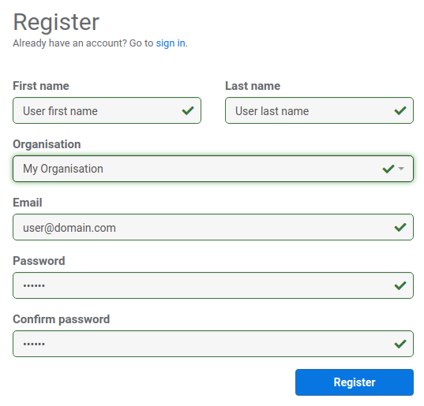

Please refer to the *Selecting my organisation* section for further clarifications about this component.

1. Click on the *Register* button
2. Wait for the confirmation email

### **From an invitation**

1. Follow the link you received in the email
2. Fill in the form
3. Click on the *Register* button
4. Wait for the confirmation email

### **Selecting my organisation**

Start typing the name of your organisation in the organisation combobox anc check the list of organisations that is displayed. If you see your organisation listed, you must select it from within the list.

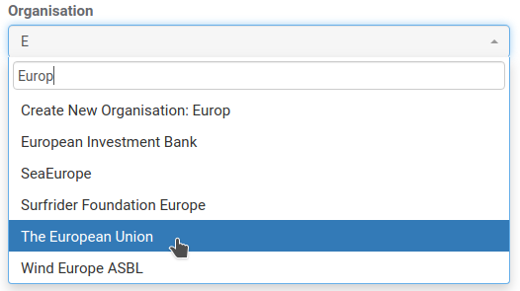

If your organisation doesn’t exist yet, the system will advise you to create a new organisation from within the list.

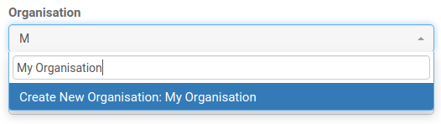

# **Reset Password**

In case you forgot your password you can create a new password following the next steps:

1. Click on Forgot my password
2. Enter your email address and press the *Reset* button
3. You will receive an email containing a link to reset your password
4. Click the link and enter your new password
5. Press the *Reset* button

# You have now changed your password.

# **Sign in**

To sign in enter your email address and your password and press the *Sign in* button.



# **Sign out**

To sign out click on the cog icon in the top right of the screen and select *Sign out*.



# **Profile**

## **How to complete your profile?**

To be able to create new commitments you need to complete your personal and organisation profiles.

### **Your personal profile**

1. Click on the cog icon in the top right of the screen and select *My profile*



1. Click on the *Edit* button
2. Complete any missing information

**\*** First name, last name and phone number are mandatory fields.

1. Click on the *Update* button

### **Your organisation profile**

1. Click on the cog icon in the top right of the screen and select *My organisation*



1. Click on the *Edit* button
2. Complete any missing information

**\*** Organisation name, entity type, address, postal code, city and country are mandatory fields.

**\*** The application will try to automatically geocode your address and display its location on the map. You can, nevertheless, adjust the position by dragging the blue pin on the map.

1. Click on the *Update* button

# **Invite a colleague**

You can easily invite other colleagues belonging to your organisation by following the next steps:

1. Click on the cog icon in the top right of the screen and select *My organisation*



1. Click on the *Invite a colleague* button
2. Enter the email of your colleague

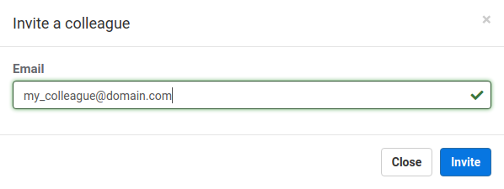

1. Click on the *Invite* button

# **Delete a user**

A user can be deleted at any time. Deleting a user will disable him from logging in to the application. A user should be deleted when, for example, leaves an organisation and should no longer have access to the system. This users can be re-approved at any point in time. To delete a user:

1. Open your *Organisation Profile*
2. On the *Organisation profile* page, you can delete a user through the *Delete* button



Deleted users can be added again to the same organisation at any time. You can simply expand the *Show deleted users* section and press the *Approve* button in the specific user you want to re-add.



# **Commitments**

There is a predefined workflow associated with commitments, from their creation, to approval, publishing, progress updating and closing. Please refer to the Annex A to better understand the entire workflow.

## **How to create a commitment?**

To be able to create commitments your personal and organisation profiles must be completed and valid.

### **What type of commitments can be submitted?**

Initiatives announced at the conference should be new, significant, and impactful actions that will tangibly advance ocean conservation. While announcements related to the four conference themes are encouraged, significant actions related to other aspects of ocean conservation will be considered for announcement as well.

### **How to create a draft?**

1. Click on the *New commitment* button in the top left of the screen
2. Fill in the form

**\*** Title, theme, progress, longitude and latitude are mandatory fields.

**\*** You can specify the geographical location of your commitment in two ways:

1. By manually entering longitude and latitude values
2. By clicking on the map at the desired location

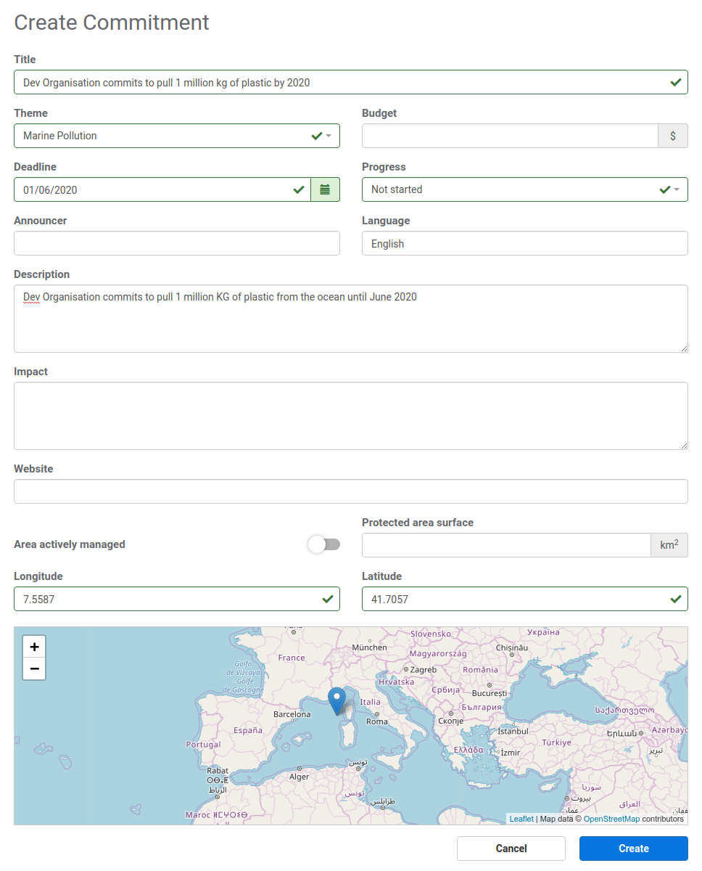

1. Click on the *Create* button

Your commitment is now created and has been assigned to the *Draft* status.

## **How to submit a commitment?**

1. Find your commitment in the dashboard. If needed you can filter the displayed commitments by using the filters available on left part of the screen.
2. Click on the row displaying your commitment



1. Click on the green *Submit* button in the top right of the screen
2. You can now enter any comment you think might be useful for the host and click on the *Submit* button



Your commitment is now submitted for validation and approval by the host. It has been assigned the *Submitted* status.

## **How do I know if my commitment has been approved?**

Once your commitment is approved by the host you will be notified by email. You can also find your commitment in the dashboard and check its status. If your commitment has been approved it will be assigned the *Approved* status.

## **What if my commitment was rejected?**

When a commitment is rejected by the host you will no longer be able to make any changes. There are several reasons for which a commitment can be rejected but it generally means that it is not in the scope of the OOC.

## **How to delete a commitment?**

You can only delete commitments that are in *Draft* status.

1. Find your commitment in the dashboard
2. Click on the row displaying your commitment
3. Click on the *Delete* button displayed on the bottom of the page

## **How to update a commitment?**

You can only update commitments if they are in the *Draft* status or if they have been already approved and published once.

1. Find your commitment in the dashboard
2. Click on the row displaying your commitment
3. Click on the *Update* button displayed on the bottom of the page
4. Make your changes on the commitment form
5. Click on the *Update* button

The status of your commitment won’t change unless you have changed the commitment’s progress, in which case, it will be assigned the *Progress update* status. The host will only need to approve your updates when you changed the commitment’s progress to *Completed*. If your final updates are approved your commitment will no longer be editable and it will be assigned the *Closed* status.

## **I received an email asking for more information, what does it mean?**

You can receive an email asking for more information either when you submit a commitment or when you make an update to an existing commitment changing its progress to *Completed*. This happens because the host didn’t approve your new commitment or your progress update. In such cases the host, normally adds a comment with the reason for such demand. You’ll be able to further edit your commitment with the necessary additional information requested by the host by following the link provided in the email.

## **How to search my commitments?**

You can search all commitments in the dashboard through the combined use of several filters:

* Text search field, that will search within the commitment’s title, abstract and impact.



* Area of action checkbox section, where you can select one or multiple themes

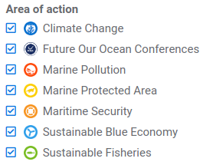

* Year combobox, where you can select either a specific year or all

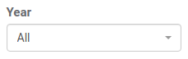

* Progress combobox, where you can select either a specific progress percentage or all

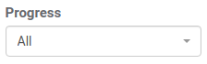

* Status checkbox section, where you can select one or multiple status of commitments

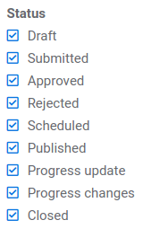

Whenever you change one of these filters a new search is performed and only the commitments matching your search criterias will be displayed in the table.

## **How to view commitments that were already made public?**

To be able to view all commitments, from all organisations, that have already been made public you have to select the *All published commitments* tab. You’ll have access to the mapping application where all commitments are made public. You can use this application to search and filter commitments by theme, country, year and any keyword you may be looking for.

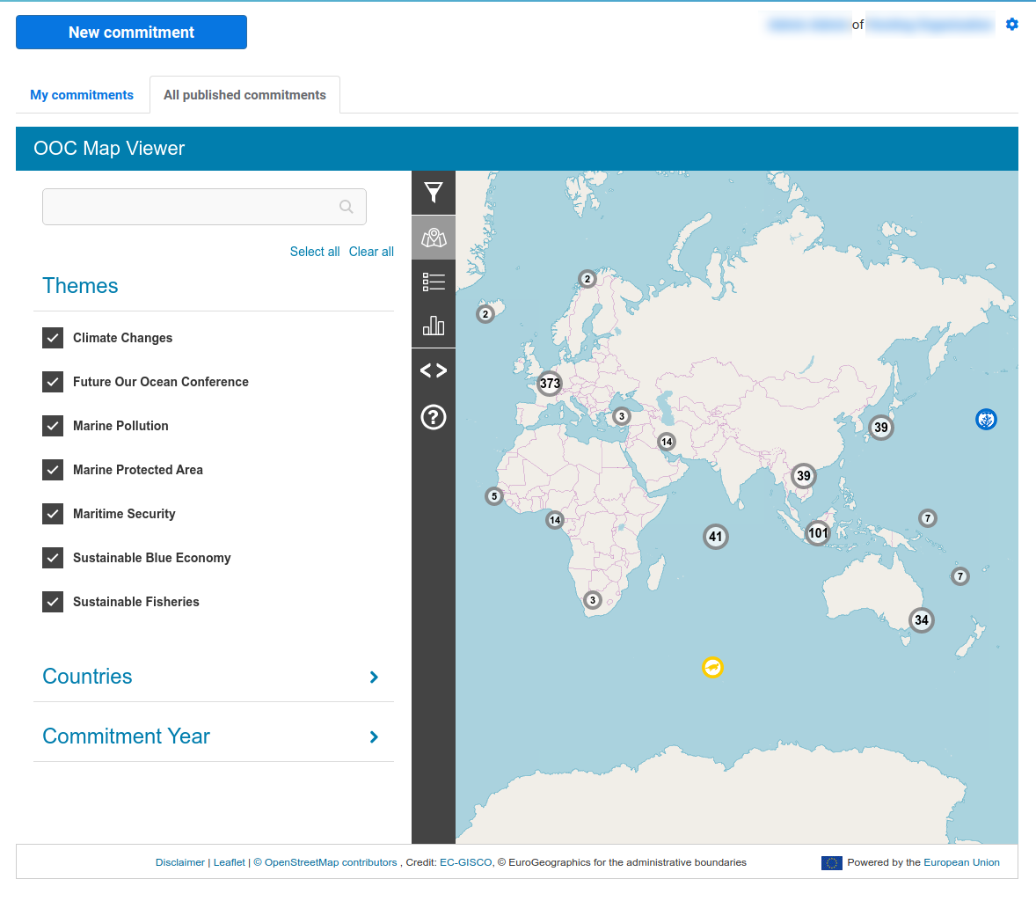

# **Annex A - Commitment Workflow**